CSA1110 – OBJECT ORIENTED ANALYSIS & DESIGN

EXP 5 ONLINE COURSE RESERVATION SYSTEM

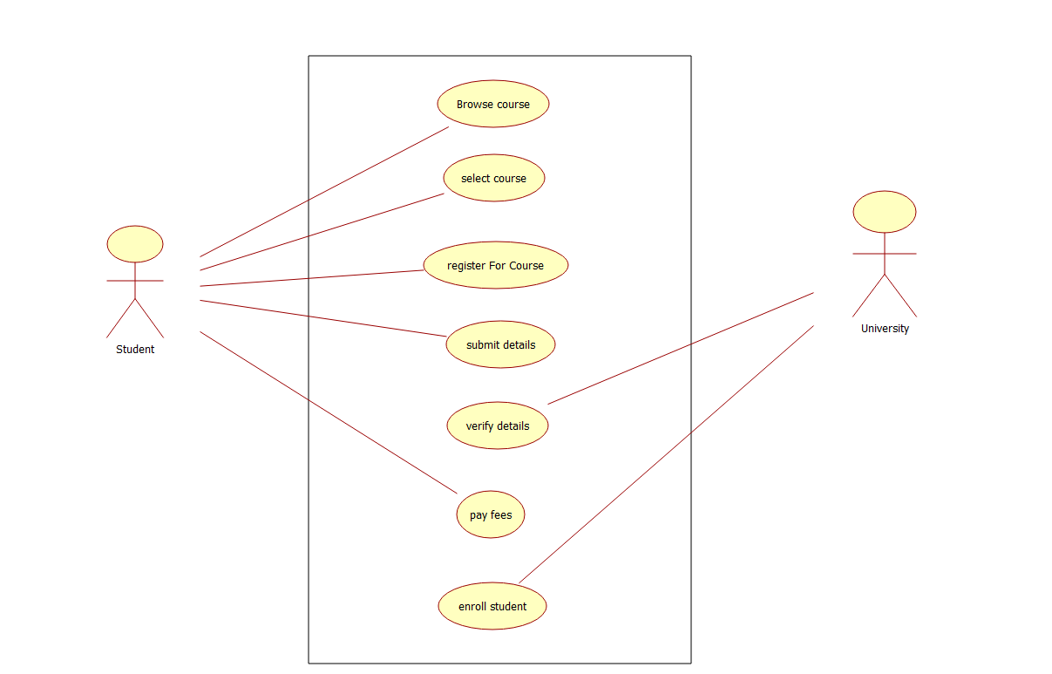
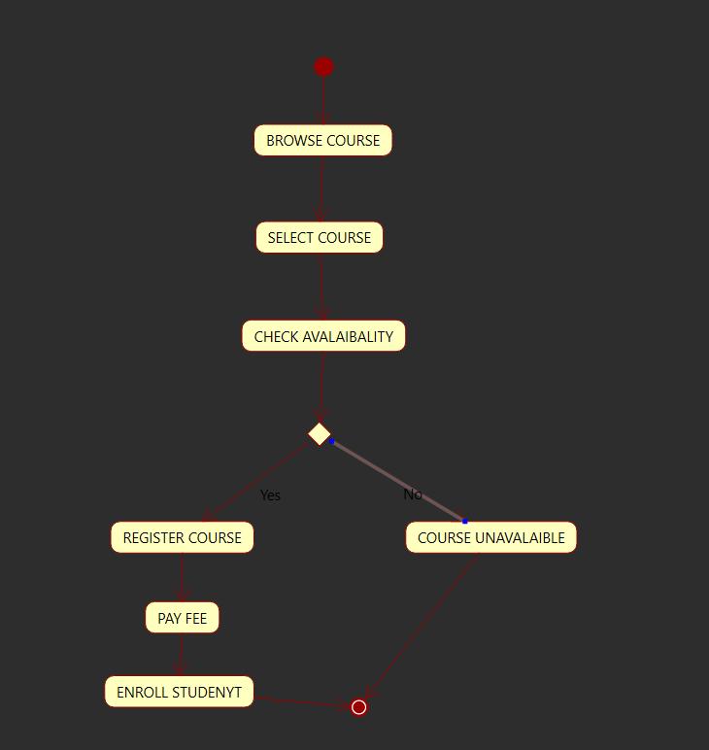
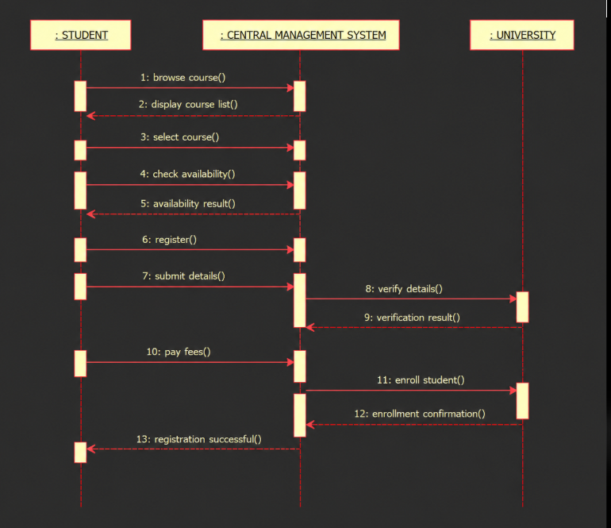

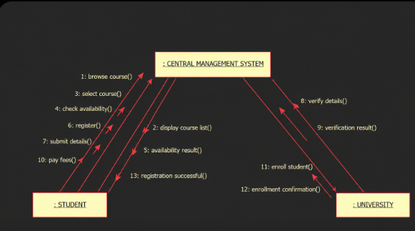

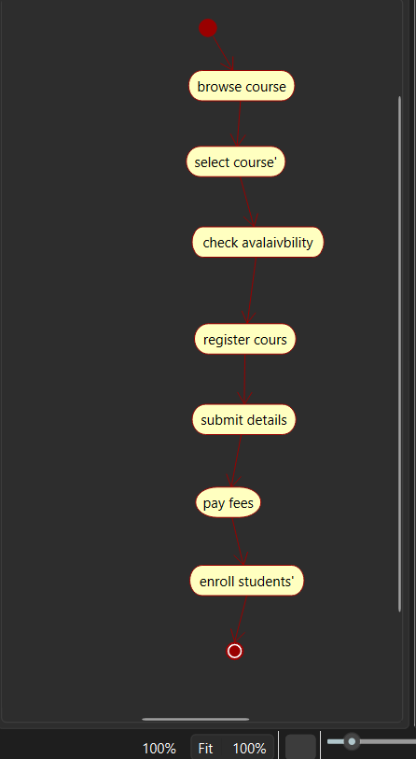

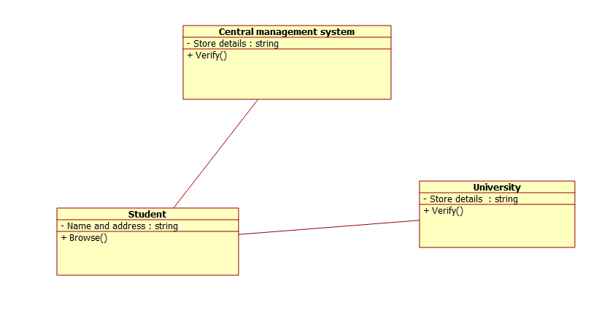

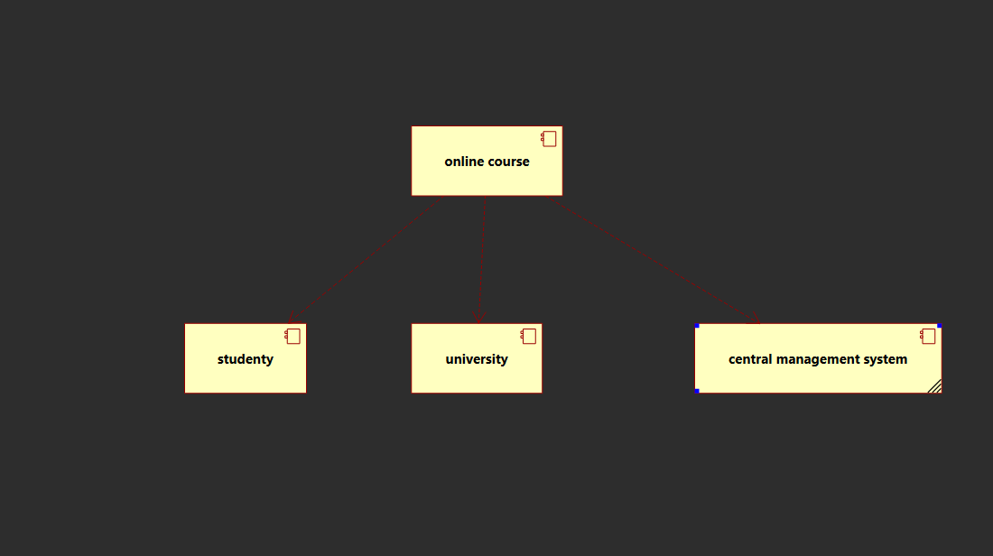

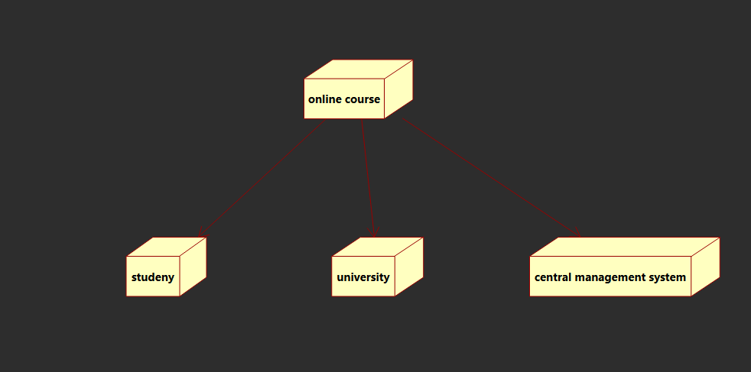

CODE

class CourseReservation:
def __init__(self):
self.courses = {
"Python Programming": 3,
"Java Programming": 2,
"Data Structures": 4
}

def display_courses(self):
print("Available Courses:")
for course, seats in self.courses.items():
print(course, "- Seats:", seats)

def check_availability(self, course):
return self.courses.get(course, 0) > 0

def reserve_course(self, student_id, course):
if self.check_availability(course):
self.courses[course] -= 1
print("\nEnrollment Successful!")
print("Student ID:", student_id)
print("Selected Course:", course)
print("Remaining Seats:", self.courses[course])
else:
print("Course unavailable or seats are full.")

reservation = CourseReservation()
reservation.display_courses()

student_id = input("\nEnter Student ID: ")
course = input("Enter Course Name: ")

reservation.reserve_course(student_id, course)

